CSF Mission Trip Application | 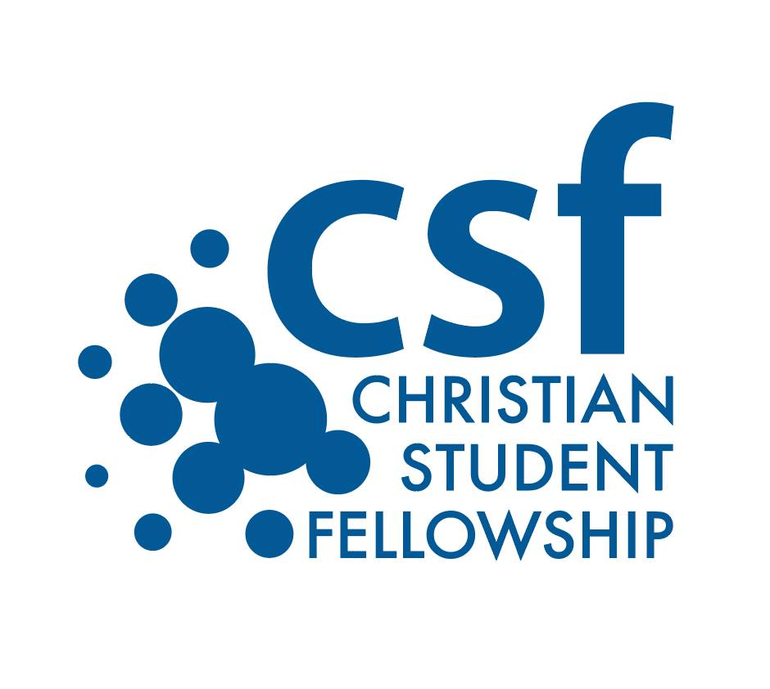

Contact Information
Full Legal Name
Phone
E-Mail Address
Do you have a Passport? | Passport #:

Trip Interest

Please check all of the trips you’re interested in:
Jan 3-6 – FAME
March 10-15 - Refugees
June 5-12 - Haiti

Interests

Tell us which areas you are most interested in volunteering
Playing with kids
Vacation Bible School
Painting
Construction
Teaching English
Sports ministry
Arts and Crafts
Music/Worship
___ Team Devotions
___ Photography/videography

Please tell us why you’re interested in going on a CSF Mission Trip. How willing are you to try things that are different than you’re used to?

Do you have any health-related issues or allergies that could be of concern on this trip? ___ Yes ___ No
If Yes, please explain:

Briefly describe some ways you currently minister to others (not job titles or positions). For example, “I minister by being a trusted listener for people who are going through hard times” or “I like to invite people to ride to church with me” or “I pray for friends when they are struggling”….

Person to Notify in Case of Emergency
Name
Street Address
City ST ZIP Code
Phone
E-Mail Address

Agreement and Signature
I understand that as a group trip, it is essential that team members be committed to being involved with CSF prior to leaving. Participating at The Edge is important to being part of the same community
I understand if I don’t make an effort to be involved in CSF (regularly attending The Edge and other activities), I may not be allowed to go on the trip.

Applications are due November 28th, 2016 with a $50 non-refundable deposit for EACH TRIP you’re applying for.

Name (printed)
Signature
Date

